**ACCESS CONTROL DOOR SYSTEM WEBAPP**

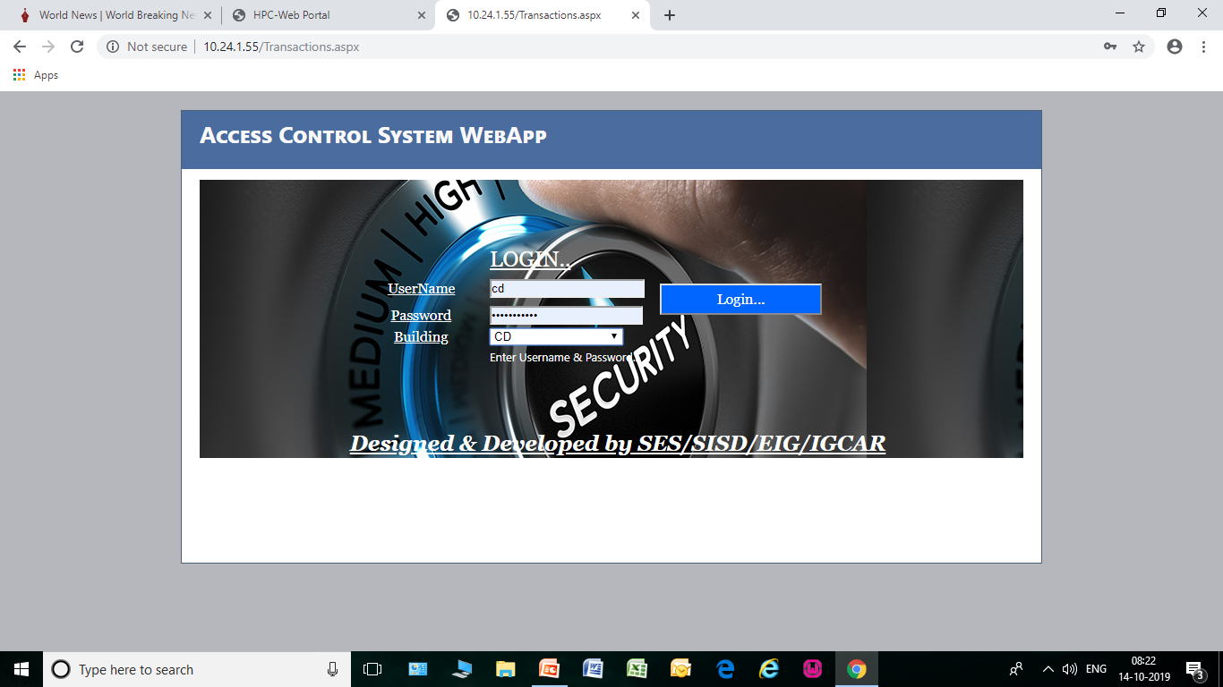

**Login to 10.24.1.55/ with valid User name and Password.**

**For accessing Annex first floor at CD**

**User name: cd**

**Password : \*\*\*\*\*\*\***

**Building : CD**

**Click to login.**

**For accessing New workstation & Anunet room at CD**

**User name: comp**

**Password : \*\*\*\*\*\*\***

**Building : comp**

**Click to login.**

**About Transctions Page**

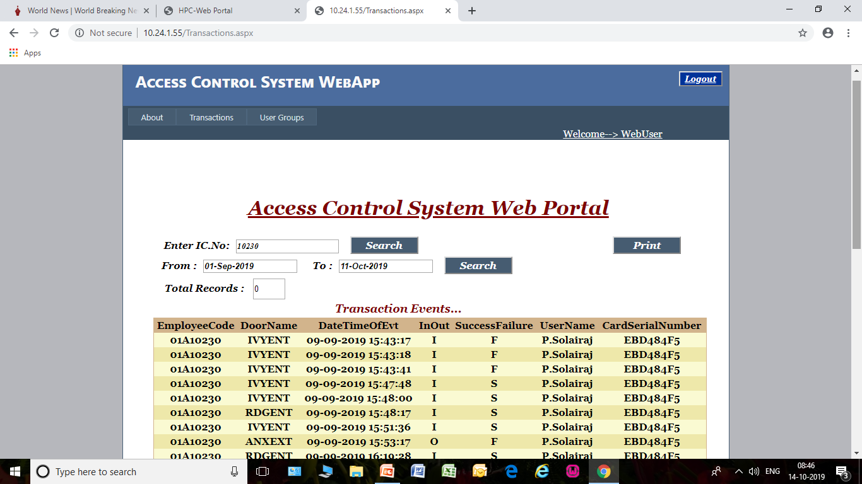

**Access Control System Web Portal has two pages. One is ‘Transaction’ and another one is ‘User Groups’**

**Transaction is only use to see or search the detail of Employee code, Door Name(visiting area), Entry date & time, Employee Name and CSN(Card Serial Number).**

**About User Groups Page**

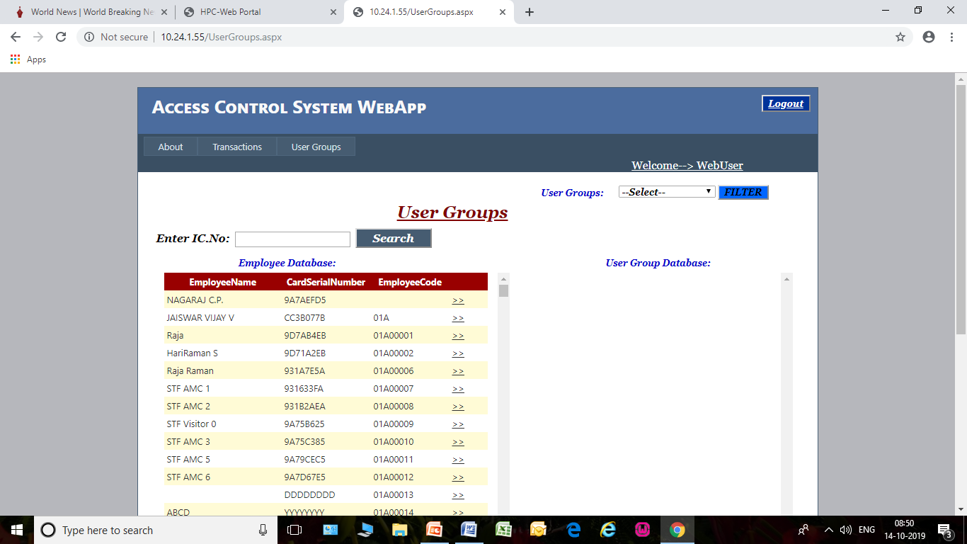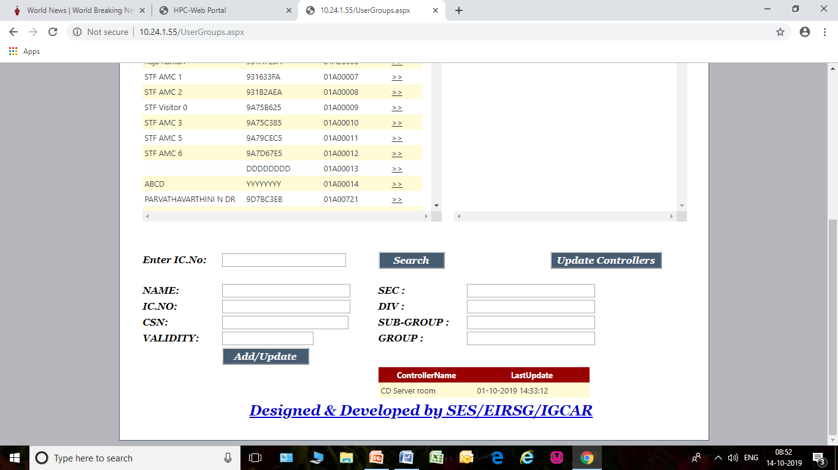

**User groups have two Data base. One is Employee Database and another one is User Group Database.**

**Employee Database is use to Search, add / update employee details in Employee Database.**

**User Group Database is use to give privilege (Area of Entry Permit) to a Person.**

**Use of Search field**

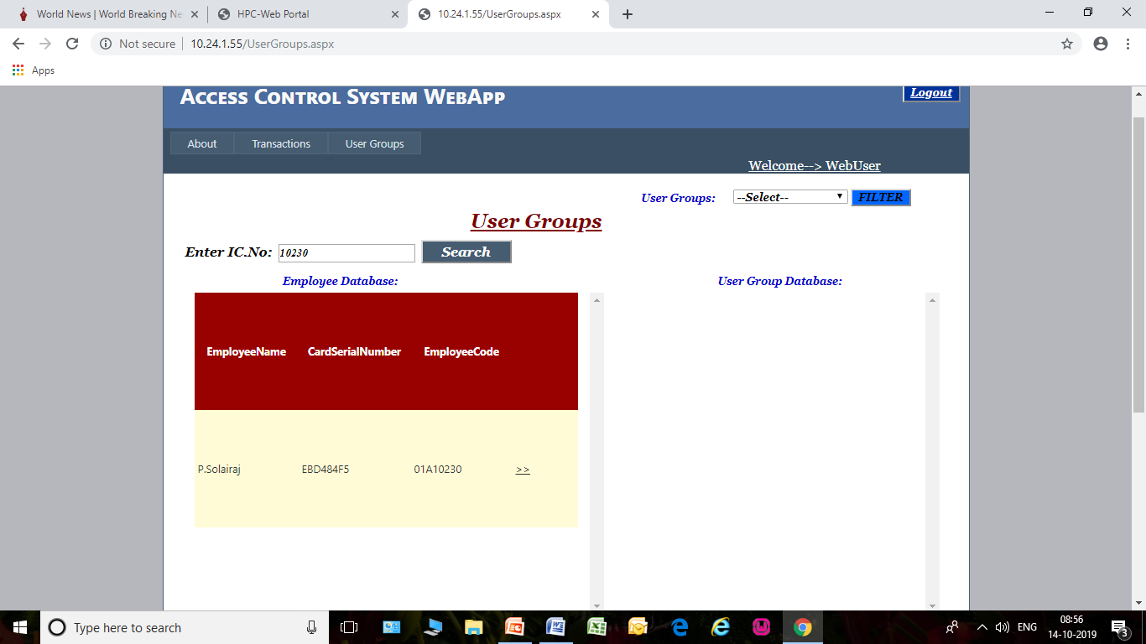

**In User Groups when enter the IC No in search field, we can able to check particular employee name is in the list or not in Employee Database.**

**In Employee Database this symbol >> is use to add Employee name and give privilege (Area of entry permit) in User Group Database.**

**Add / Update Employee name**

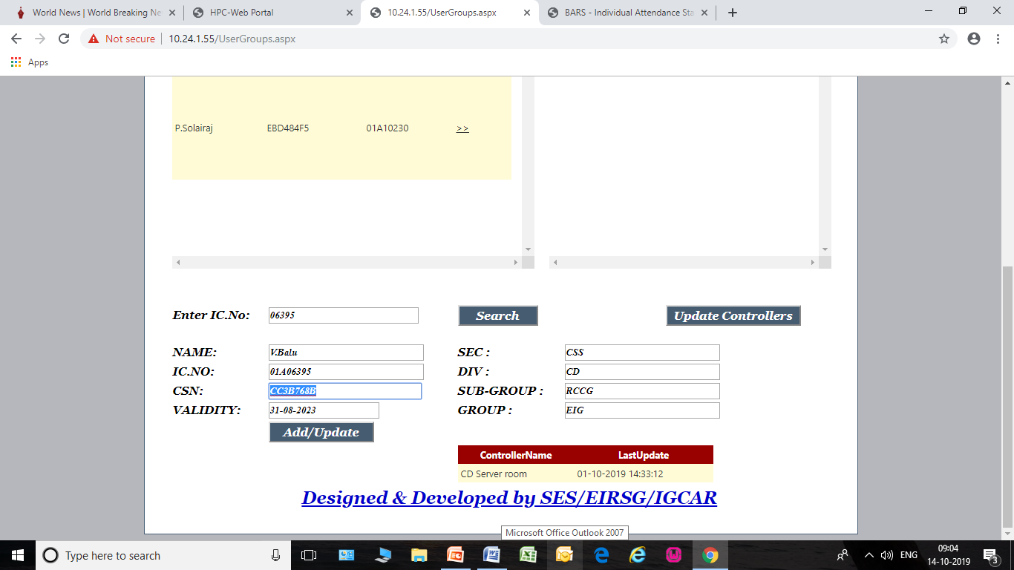

**If we want to add Employee name in Employee Database first we fill his details in particular field in the Employee Database then click Add / Update button. Like that we can Add /Update many no of Employee name in data base.**

**If all Employee name was Add / Update in Employee Database finally we should click Update Controllers button. When we click Update Controller button that time controller get & save data from database.**

**Note:**

**CSN (Card Serial No) is automatically detect in ‘Transaction’ page when show the ID card on Access control door reader. Copy the CSN from ‘Transaction’ page and to paste it ‘User groups’ Employee Database.**

**Area of Entry Permit**

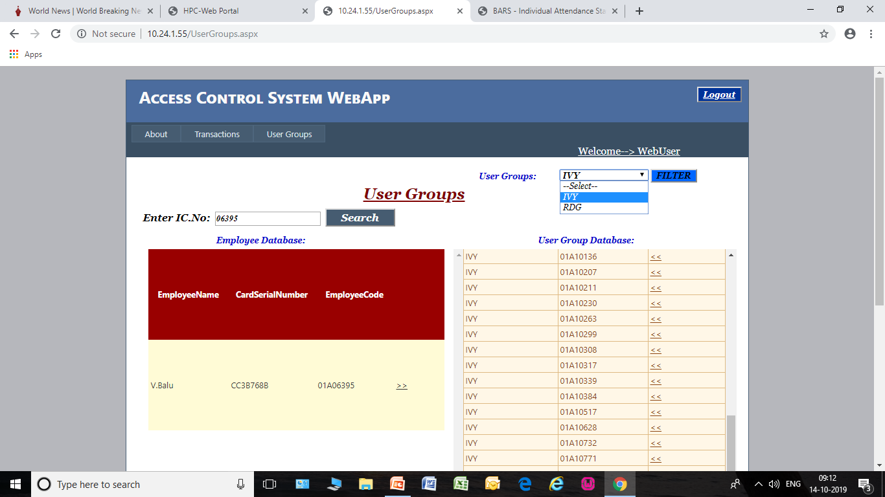

**After add employee name in Employee Database, then should add his name and give privilege(Area of entry permit) in User Group Database by click the following symbol >> in employee data base. Before we select IVY / RDG Filter In user group for to give access in particular area and click the symbol >> employee name in Employee Database. Now we can able to give access in particular area to employee. Like that we can able to add & give privilege many Employee name in User Group Database. Finally we should click Update Controllers button.**

**Remove Access**

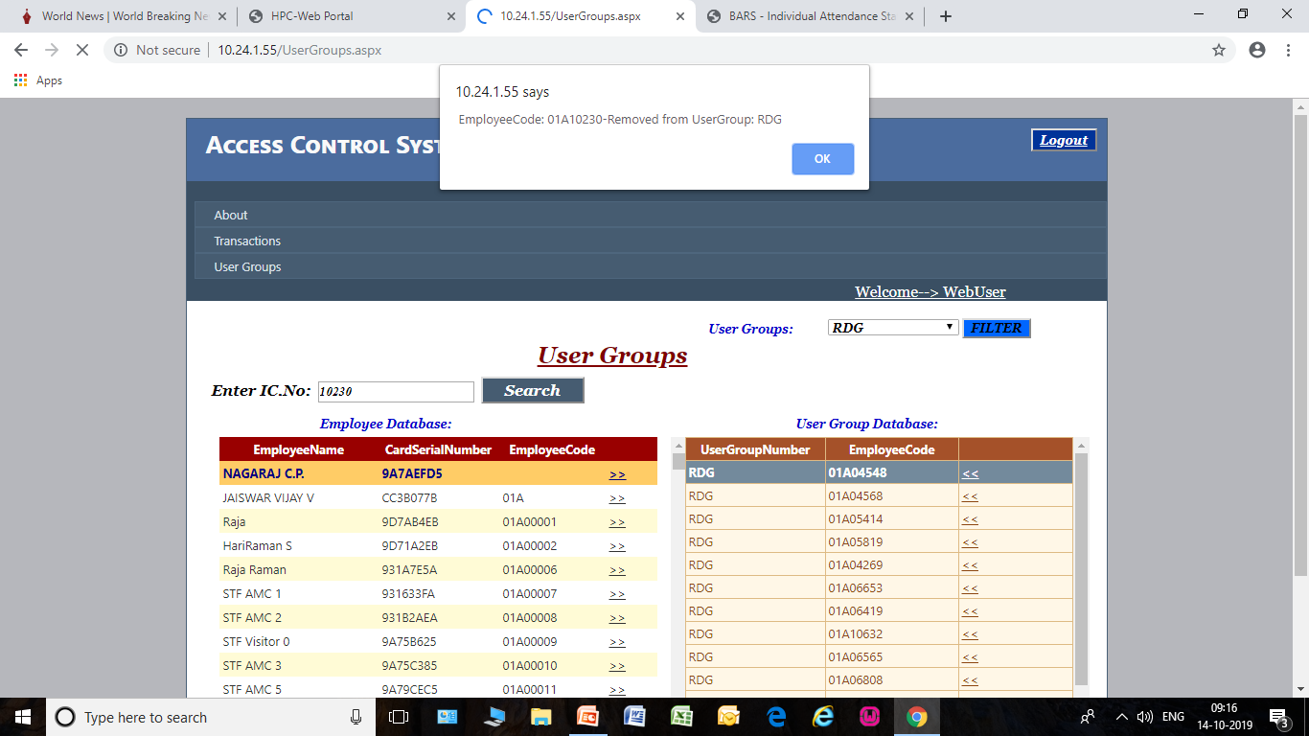

**If need to remove access a employee from a particular area, select User Groups filter IVY / RDG and click the following symbol << of employee code in user group database. Like that we can remove many no of Employee name in data base.**

**If some Employee name was removed in Employee Database finally we should click Update Controllers button.**